Optical Fiber Image Transmission Board Spec Sheet

Overview
This optical fiber board is designed for high performance and high reliability data transmission requirements, featuring an advanced star networking architecture that supports one central node for efficient connection and management of up to 16 sub-nodes, building a stable and scalable network topology.
The video transmission module integrates core communication technologies such as OFDM (Orthogonal Frequency Division Multiplexing) and MIMO (Multiple Input Multiple Output), significantly enhancing spectral efficiency and link reliability. It supports flexible multi-tier bandwidth allocation (1.4MHz, 3MHz, 5MHz, 10MHz, 20MHz) and optimizes resource utilization based on actual application scenarios. At the highest configuration, up to 30Mbps transmission rate can be achieved, effectively reducing system transmission delay and significantly enhancing the overall system's data transmission capacity. Key performance advantages include:
- Long transmission distance: Video transmission supports 20km long transmission, meeting the requirements of long flight.
- High data throughput: With high rate and large bandwidth support, ensure smooth transmission of large amounts of data.
- Outstanding anti-interference performance: Combined with OFDM and MIMO technologies, it ensures stable and reliable communication in complex electromagnetic environments.
- Integrated optical fiber and video transmission: Supports dual-mode transmission of optical fiber and video transmission to meet various application requirements.

Packaging list

- Image transmission optical fiber board - Aerial end *1
- Image transmission optical fiber board - Ground end *1
- Connection cable *2
- Network port communication cables * 2
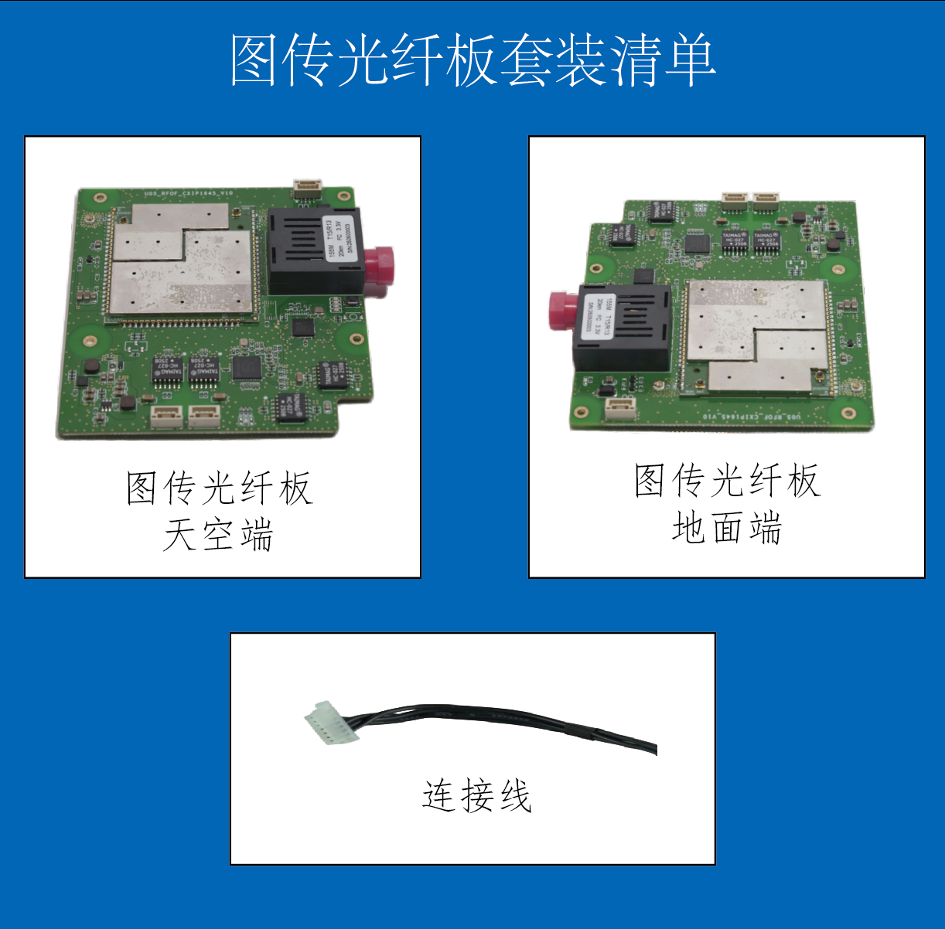
Image transmission optical fiber board - Groundl end
Image transmission optical fiber board - Aerial end

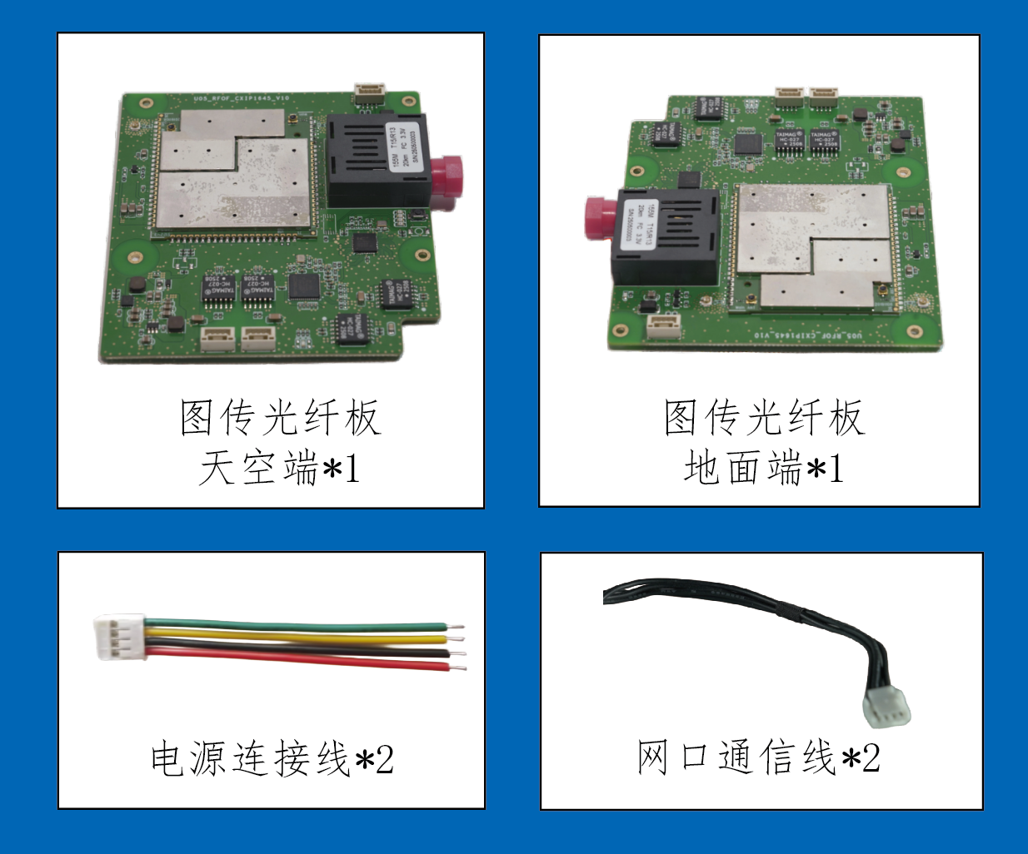
Network port comm. cables
xConnection cable
Image transmission optical fiber board - Groundl end
Image transmission optical fiber board - Aerial end

Product dimensions and interfaces

Mechanical parameters
Product size (length X width) : 90.95mm x 84.47mm
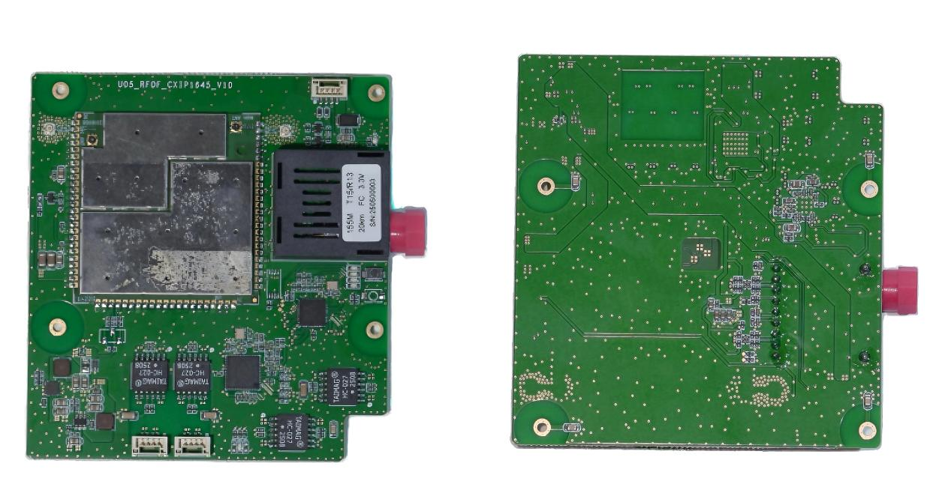

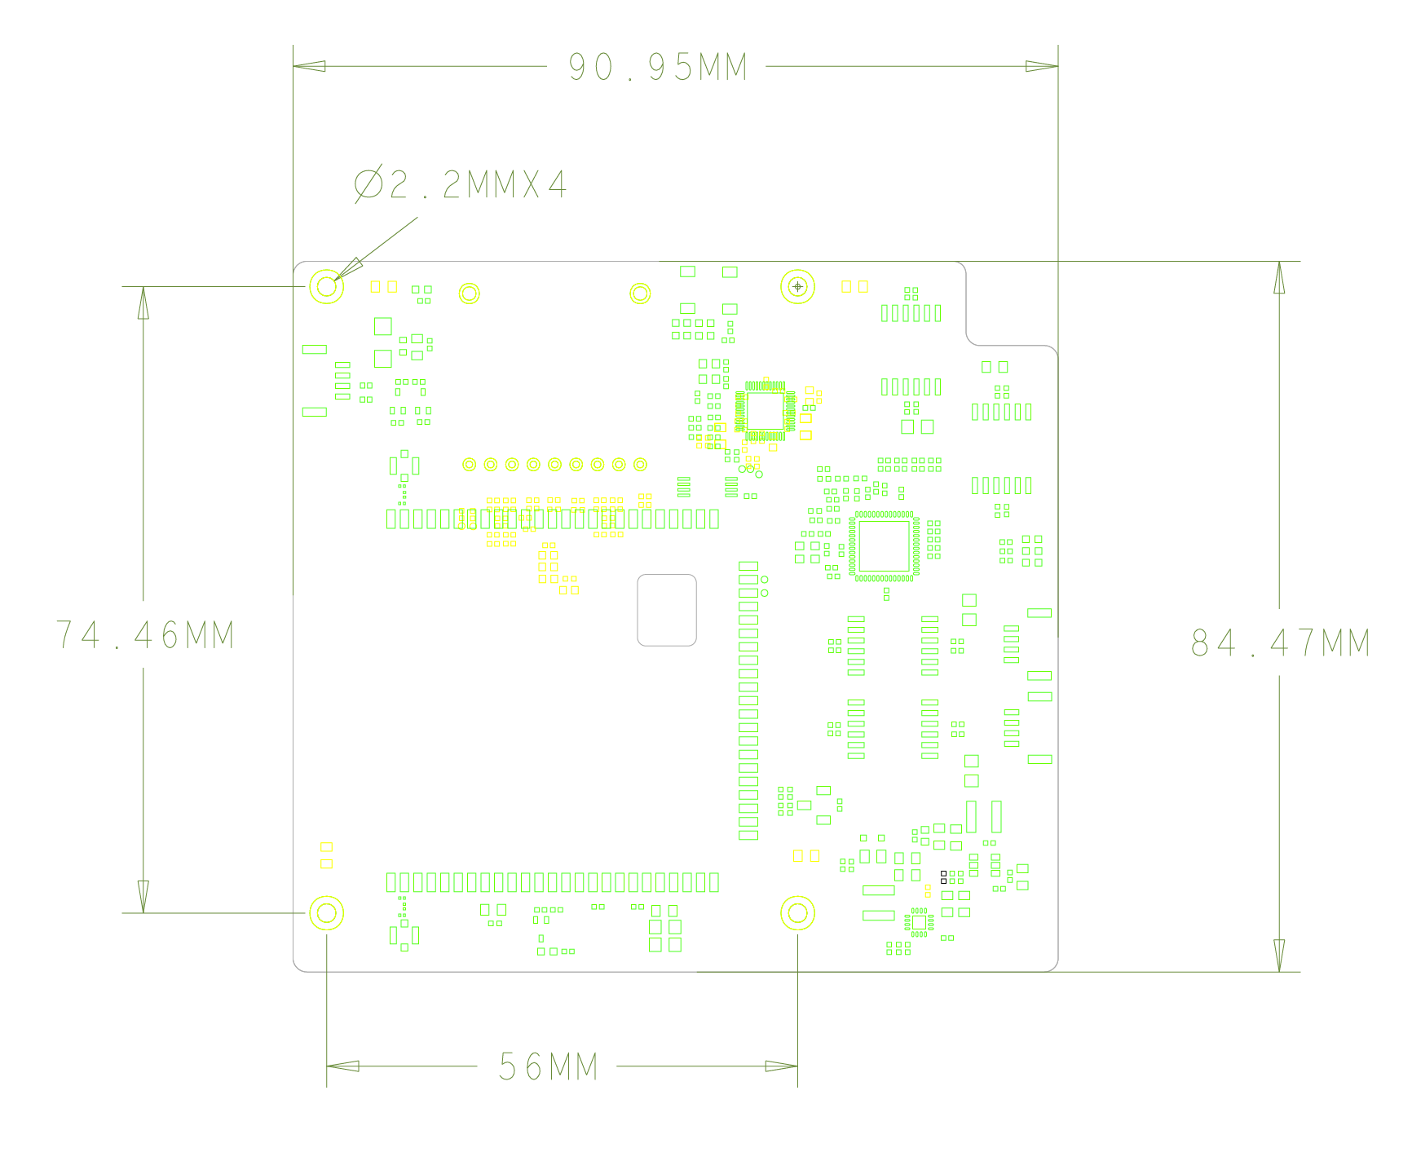

Interface definitions and functions
Power port

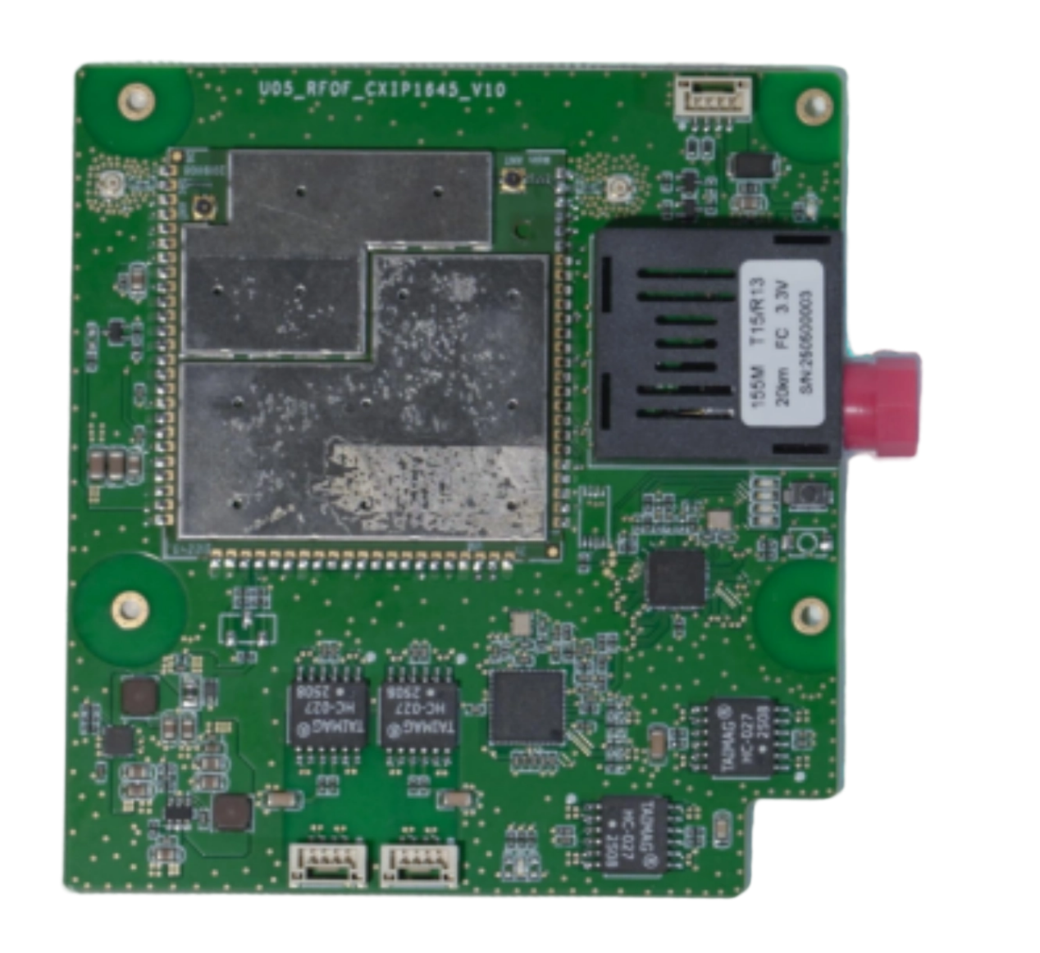
Fiber optic port
Network Port 1
Port 2

Power port pin definition
Pin | Signal | Voltage
P1 | UART_TX | 3.3 V
P2 | UART_RX | 3.3 V
P3 | GND | GND
P4 | VCC | 12V+

Port 1 pin definition
Pin | Signal | Voltage
P1 | TX- | Default
P2 | TX+ | Default
P3 | RX- | Default
P4 | RX+ | Default

Functional features
- Star networking with key technologies such as OFDM and MIMO
- Dual-antenna: single-antenna transmission, dual-antenna reception
- Supported wireless operating bands: 2401.5-2481.5MHz, 1427.9-1447.9MHz, 806-826 MHZ
- Wireless bandwidth can be configured: 1.4 MHz / 3 MHz / 5 MHz / 10 MHz / 20 MHz, two nodes support one-way maximum 30 MBPS
- Modulation: Supports QPSK, 16QAM, 64QAM modulation
- Encryption options: ZUC, SNOW3G, AES
- Maximum transmission power: 25 DBM ±2
- Maximum transmission distance: 20km
- Node capacity: Up to 16 access nodes
- Configuration management: Fulfill basic configuration/reporting/query functionality via WEB UI
- Fiber optic module: Supports stable fiber transmission up to 20km

Technical Parameters
Module Category | Parameter Categories | Parameter items | Detailed parameters
Basic Parameters |  | Supply voltage | 12V
Basic Parameters |  | Weight | 48g
Basic Parameters |  | Size (length X width mm) | 90.95 X84.47
Fiber optic transceiver | Interface |  | FC interface
Fiber optic transceiver | Transmission distance |  | 0-20km
Fiber optic transceiver | Data transfer rate |  | 155Mbps
Wireless video transmission | RF | Power rating | 2.4G/1.4G/800M, 25dBm±2
Wireless video transmission | RF | Radio frequency band | 2401.5 to 2481.5 MHz  1427.9 to 1447.9 MHz  806-826MHz
Wireless video transmission | RF | Sensitivity (access) | 2.4G (24415 channel number) :  20MHz -99dBm  10MHz -103dBm  5MHz -104dBm  3MHz-106dBm
Wireless video transmission | RF | Sensitivity (access) | 1.4G (14379 channel number)  20MHz -99dBm  10MHz -103dBm  5MHz -104dBm  3MHz -106dBm
Wireless video transmission | RF | Sensitivity (access) | 800M (8160 channel number)  20MHz -99dBm  10MHz -103dBm  5MHz -104dBm  3MHz -106dBm
Wireless video transmission | RF | Sensitivity (BLER<=3%) | 2.4G (24415 frequency points) :  20MHz -97dBm(5Mbps)  10MHz -96dBm(5Mbps)  5MHz -93dBm(5Mbps)  3MHz -98dBm(2Mbps)
Wireless video transmission | RF | Sensitivity (BLER<=3%) | 1.4G (14379 frequency points) :  20MHz -97dBm(5Mbps)  10MHz -96dBm(5Mbps)  5MHz -91dBm(5Mbps)  3MHz -97dBm(2Mbps)
Wireless video transmission | RF | Sensitivity (BLER<=3%) | 800M (8160 points) :  20MHz -97dBm(5Mbps)  10MHz -97dBm(5Mbps)  5MHz -94dBm(5Mbps)  3MHz -98dBm(2Mbps
Wireless video transmission | Transmission mode | Unicast, multicast, broadcast | Support
Wireless video transmission | Transmission mode | Transmission mode | Single-antenna transmission, dual-antenna reception
Wireless video transmission | Transmission mode | Data link | Master-slave two-way data communication
Wireless video transmission | Transmission mode | Uplink and downlink matching | The uplink and downlink time slot ratio of the central node supports 2D3U/3D2U/4D1U/1D4U
Wireless video transmission | Operating bandwidth | Support bandwidth | 1.4 MHz / 3 MHz / 5 MHz / 10 MHz / 20 MHz
Wireless video transmission | Rate | Peak rate | Two nodes support a one-way maximum of 30Mbps
Wireless video transmission | Rate | Rate levels | Adaptive average distribution system rate
Wireless video transmission | Encryption | Encryption algorithm | ZUC, SNOW3G, AES - three encryption options available
Wireless video transmission | Modulation | Modulation method | Supports QPSK, 16QAM, 64QAM modulation
Wireless video transmission | Anti-interference | Dynamic frequency modulation | Support frequency hopping
Wireless video transmission | Retransmission | HARQ retransmit | Support
Wireless video transmission | Network capacity | Number of network nodes | Up to 16 access nodes
Wireless video transmission | Sleep | DRX | Master node control, slave nodes allow access to DRX, 160ms cycle wake-up
Wireless video transmission | Transmission distance | Limit transmission distance | 20km
Wireless video transmission | Delay | Module air interface delay | UL is unidirectional, with a delay of no more than 15ms  DL unidirectional, delay <=15ms
Wireless video transmission | Delay | Startup delay | Central node/slave node startup delay 15 seconds
Wireless video transmission | System control | Parameter configuration | Transmit power/frequency point/bandwidth (change in real time), band (change not in real time)
Wireless video transmission | System control | Status/Parameter reporting | Connection status /rsrp/ snr/distance/ uplink/downlink throughput, etc
Wireless video transmission | Configuration Management | WEBUI | Satisfy basic configuration/reporting/query functionality
Wireless video transmission | Software upgrade | OTA | Support OTA upgrades, support local and remote upgrades
Wireless video transmission | Transmitter spurious | <-36dBm@BW=1kHz | 9KHz=<f<150KHz
Wireless video transmission | Transmitter spurious | <-36dBm@BW=10kHz | 150KHz=<f<30MHz
Wireless video transmission | Transmitter spurious | <-36dBm@BW=100kHz | 30MHz=<f<1000MHz
Wireless video transmission | Transmitter spurious | <-36dBm@BW=1MHz | 1 GHz = < f < 12.75 GHz
Wireless video transmission | Adjacent channels  Leak ratio | ACLR | < 29.2 dBc @ E - UTRA1  < 32.2 dBc @ UTRA1  < 35.2 dBc @ UTRA2
Wireless video transmission | Power consumption | Peak | Power consumption value at maximum rate: 700mA±15%
Wireless video transmission | Temperature range | Operating temperature | -20°C to 75°C
Wireless video transmission | Temperature range | Storage temperature | -40°C to 85°C
Wireless video transmission | Humidity range | Working humidity | 5% to 95% (no condensation)

