AI Intelligent Reconnaissance Module

Specification Sheet

Overview
The AI Intelligent q Reconnaissance Module is an AI vision-aware tracking kit designed specifically for drones, integrating high-performance target recognition and dynamic tracking. The product integrates a 50MP fixed-focus visible light camera, a 3.3x ultra-clear optical zoom visible light camera, a high-resolution thermal imager, a high-precision laser rangefinder, and is equipped with a lightweight three-axis gimbal and an adaptive shock absorption module, along with auto-focus and gimbal stabilization algorithms to ensure stable and clear high-altitude operation images. At the same time, by integrating deep learning algorithms with high-performance intelligent chips, it can perform tasks such as multi-target recognition and target tracking in visible light images.
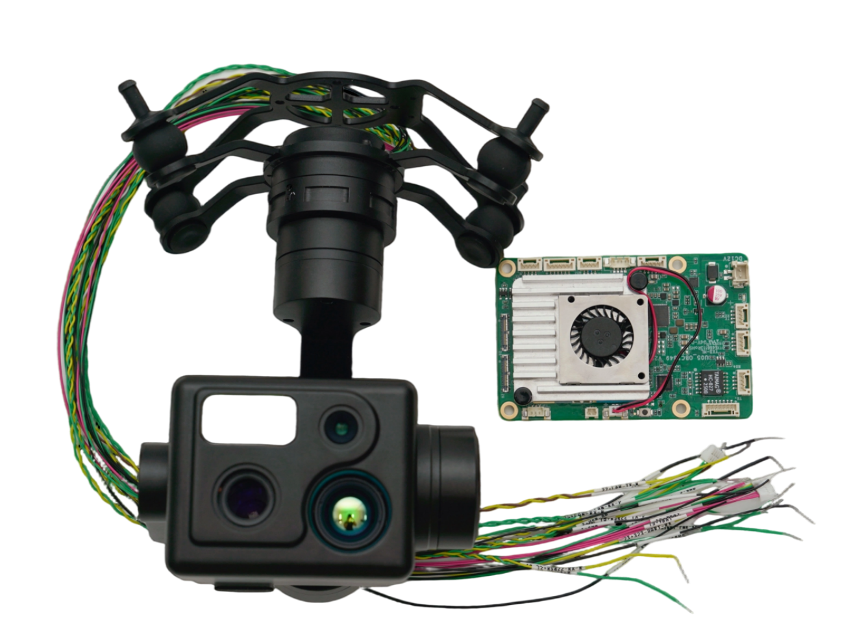

Packaging Checklist
- AI main board *1
- Quad camera payload *1
- Power cable *1
- Serial comm.port*1
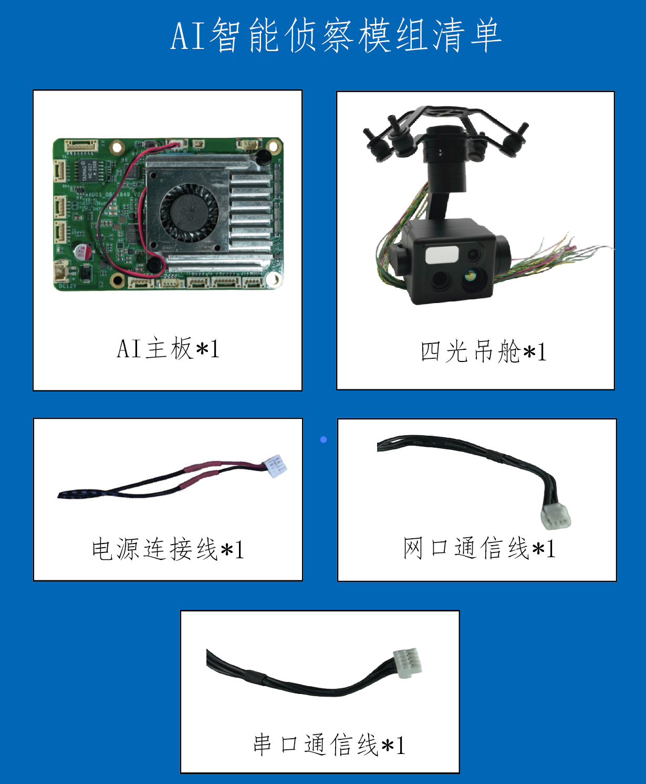
- Network comm.port*1
AI intelligent recogniction module packing list
Serial comm.cable
Network comm. cable
Power cable
Camera
AI main board

Product Dimensions

AI image processing board
Dimensions (length width height) : 85x56x15mm
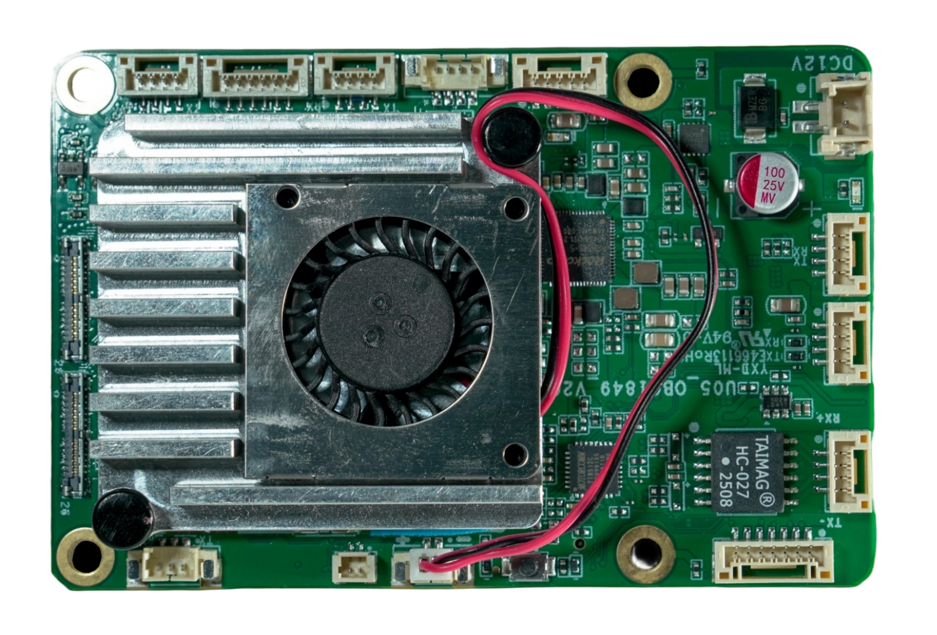
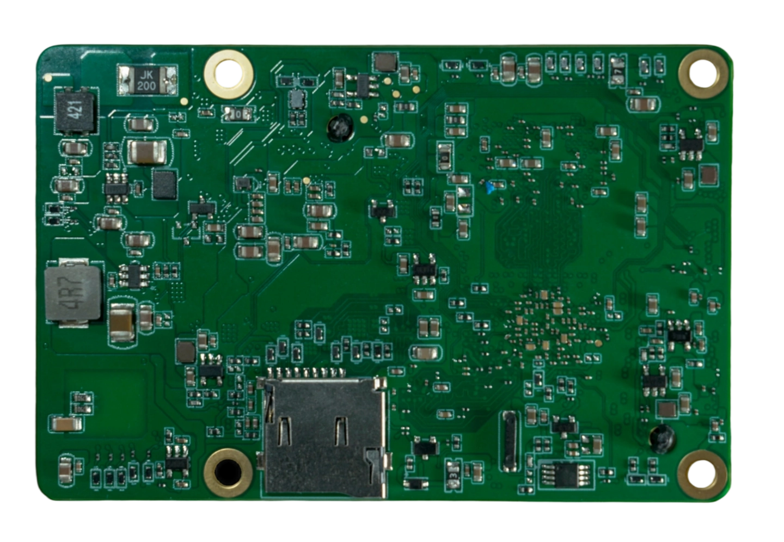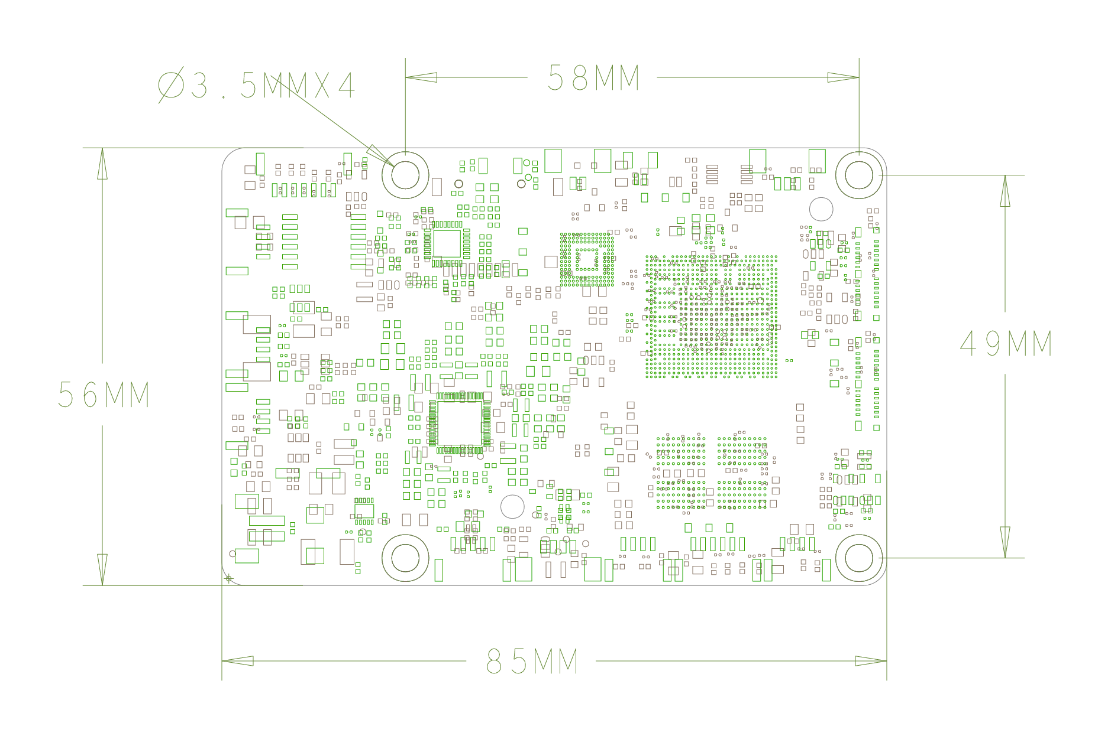

4-in-1 gimbal
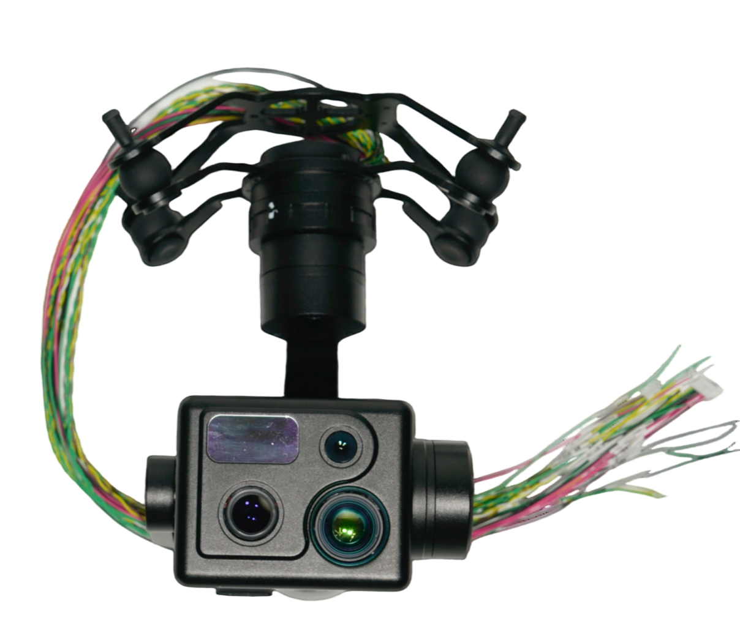
Infrared camera
Zoom camera
Wide-angle camera
Laser rangefinder

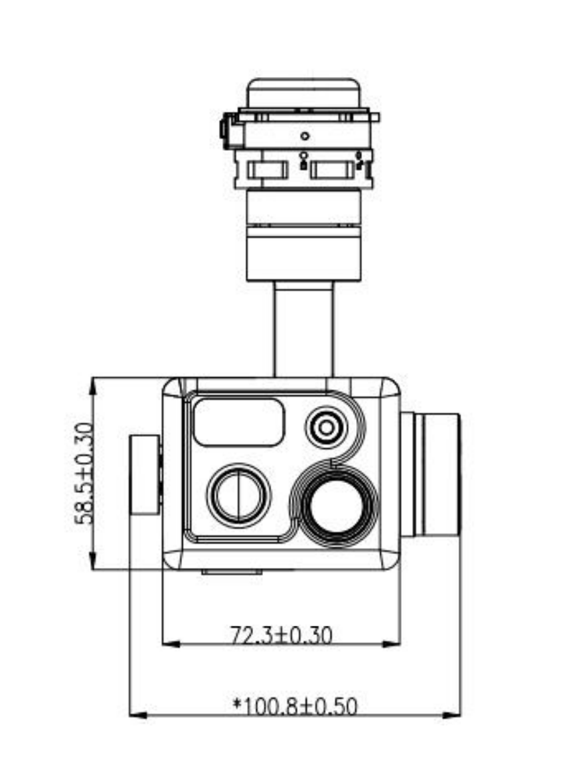
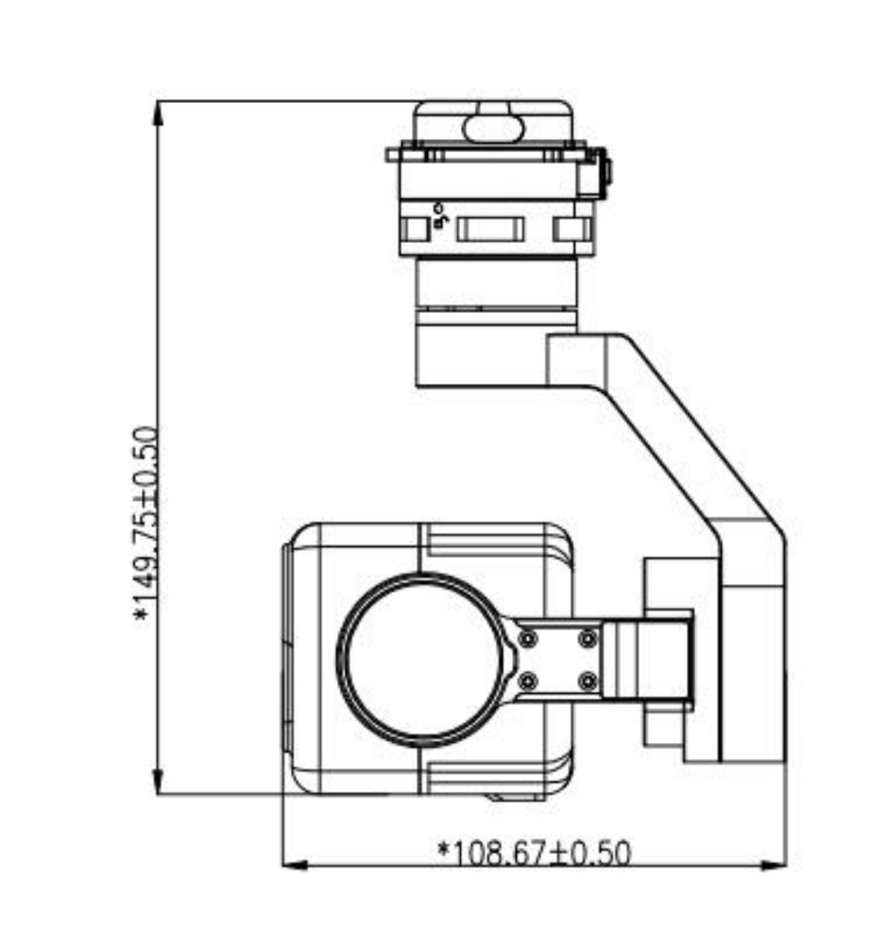

Product Interface
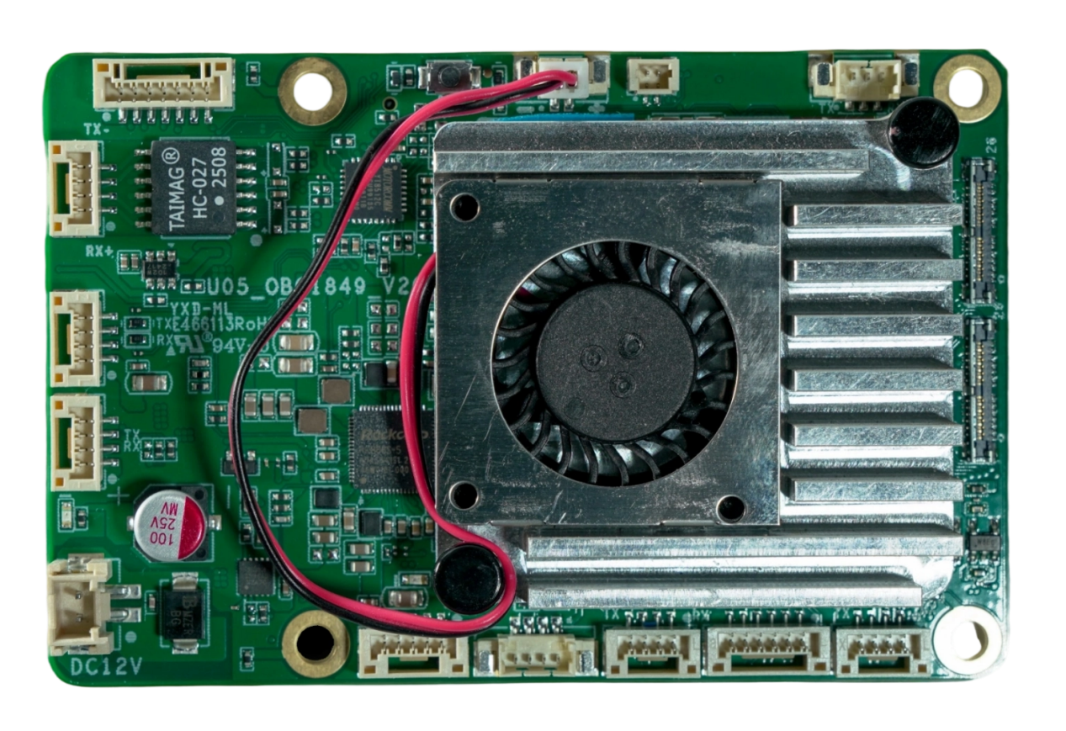
Power input port
Serial Port 2
Network port
Serial Port 1
CAM2
Debug Port
CAM1
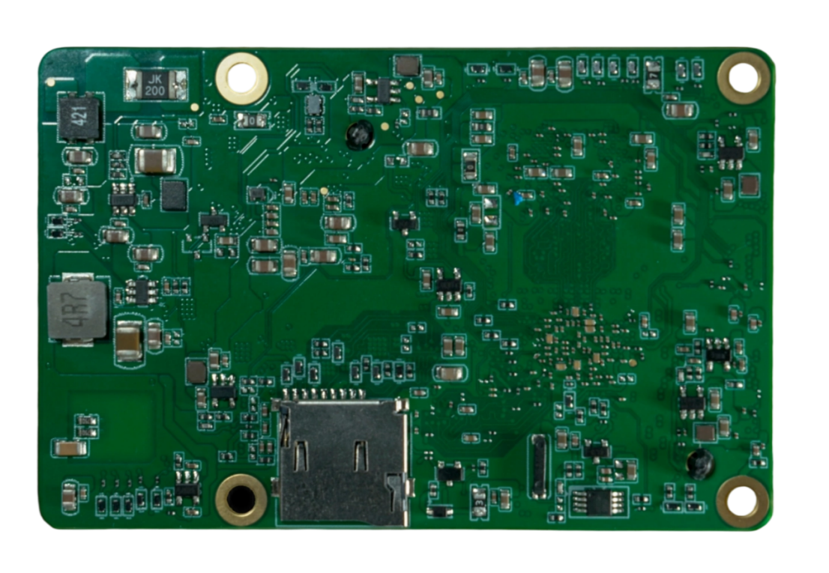
Serial 6

Serial 4+5
USB_OTG
USB_HOST
Serial 3
TF Card slot

AI image processing board pin definition
- Network port
Pin | Signal | Voltage
P1 | RX+ | Default
P2 | RX- | Default
P3 | TX+ | Default
P4 | TX- | Default

- Serial Port 1
Pin | Signal | Voltage
P1 | VCC | 5V+
P2 | UART3_RX | 3.3 V
P3 | UART3_TX | 3.3 V
P4 | GND | GND

- Serial Port 2
Pin | Signal | Voltage
P1 | VCC | 5V+
P2 | UART2_RX | 3.3 V
P3 | UART2_TX | 3.3 V
P4 | GND | GND

- Power input port
Pin | Signal | Voltage
P1 | VCC | 12V+
P2 | GND | GND

- USB_HOST
Pin | Signal | Voltage
P1 | GND | GND
P2 | GND | GND
P3 | USB2.0 _DP | Default
P4 | USB2.0 _DM | Default
P5 | VBUS | 5V+

- USB_OTG
Pin | Signal | Voltage
P1 | VBUS | GND
P2 | USB2.0 _DM | Default
P3 | USB2.0 _DP | Default
P4 | GND | GND

- Serial Port 3
Pin | Signal | Voltage
P1 | VCC | 5V+
P2 | UART6_RX | 3.3 V
P3 | UART6_TX | 3.3 V
P4 | GND | GND

- Serial port 4+5
Pin | Signal | Voltage
P1 | UART11_RX | 3.3 V
P2 | UART11_TX | 3.3 V
P3 | UART10_RX | 3.3 V
P4 | UART10_TX | 3.3 V
P5 | GND | GND
P6 | VCC | 12V+

- Serial Port 6
Pin | Signal | Voltage
P1 | UART9_RX | 12V+
P2 | UART9_TX | 3.3 V
P3 | GND | GND

- CAM1/CAM2
Pin | Signal | Voltage
P1 | D2N | Default
P2 | D3N | Default
P3 | D2P | Default
P4 | D3P | Default
P5 | D0N | Default
P6 | GND | GND
P7 | D0P | Default
P8 | GND | GND
P9 | GND | GND
P10 | D1N | Default
P11 | CLKN | Default
P12 | D1P | Default
P13 | CLKP | Default
P14 | MCLK_24M | 1.8 V
P15 | GND | GND
P16 | GND | GND
P17 | PDN | 1.8 V
P18 | I2C_SDA | 1.8 V
P19 | RST | 1.8 V
P20 | I2C_SCL | 1.8 V
P21 | VCCIO | 1.8 V +
P22 | GND | GND
P23 | VCCAF | 2.8 V +
P24 | VCC | 1.2 V +
P25 | VCC_AF | 2.8 V +
P26 | VCC | 1.2 V +

- Backup battery port
Pin | Signal | Voltage
P1 | GND | GND
P2 | VCC_RTC | 3.0 V +

- Fan outlet
Pin | Signal | Voltage
P1 | GND | GND
P2 | VCC | 5.0 V +

- I/O port
Pin | Signal | Voltage
P1 | VCC | 5.0 V +
P2 | I/O1 | 3.3 V
P3 | I/O2 | 3.3 V
P4 | I/O3 | 3.3 V
P5 | I/O4 | 3.3 V
P6 | I/O5 | 3.3 V
P7 | GND | GND

- TF card slot
Pin | Signal | Voltage
P1 | Default | Default
P2 | Default | Default
P3 | Default | Default
P4 | Default | Default
P5 | Default | Default
P6 | Default | Default
P7 | Default | Default
P8 | Default | Default
P9 | Default | Default

Features
- Automatic reconnaissance: Automatically complete reconnaissance of the target area.
- Multi-target recognition: Supports multi-type target recognition and can recognize multiple targets within the frame simultaneously.
- Long-range recognition: Can automatically recognize objects such as human bodies and vehicles within 1500 meters.
- Framing targets: Supports framing targets in visible light and outputting images of the framed objects.
- Locking: Supports manual framing and clicking the recognition box to lock the target.
- Tracking: Supports dynamic target tracking.
- Multi-channel video split-screen display: Supports side-by-side display of infrared split-wide-angle and infrared split-zoom camera videos, and can switch between zoom and wide-angle camera video streams. Zoom control is supported when the zoom camera video stream is displayed.
- Picture-in-picture display: Supports dual-channel picture-in-picture display, with the main picture showing the camera image of primary focus and the secondary picture showing other camera images.
- Precise distance measurement function: Automatically measure the actual distance of the target from the pod when the target is locked; Manual distance measurement is also supported.
- Target location calculation: The longitude and latitude of the target can be calculated based on the GPS location of the drone itself.
- Image storage: The AI image processing board supports the storage of videos recorded during the automatic search process in 1080p format and 30fps frame rate.

Technical Parameters
AI Image processing board parameters
Main control computing power (TOPS | 6
Control Protocol | Private Protocol
Support flight control | PX4
Input voltage (V) | 12
Size (length, width, height mm) | 85 * 56 * 15
Mounting hole positions (mm) | 3.5 * 4
Overall parameters of the four-light pod
Video output interface | Ethernet port
Control Signal Interface | 1 S.BUS, 1 RS422, 1 Ethernet, 1 serial port, 1 CAN
Power supply range | 10V to 28V
System power consumption | Average power consumption: ≤15W  Peak power: ≤30W
Protection class | IP4X
Operating temperature | - 20 ℃ ~ 55 ℃
Size (without shock absorption) | ≤101mm×109mm×150mm
Weight (without shock absorption) | Less than 400g
Mechanical interface type | Quick-release & fixing holes
Zoom camera
Image sensor | 48 million pixels 1/2-inch
Maximum photo size | 8000*6000 (4:3)
Video resolution | 3840×2160@30fps  1920×1080@30fps
Encoding format | H.264, H.265
Focus mode | MF, AFC, AFS
Actual focal length | 15mm-50mm
Equivalent focal length | 81.13 270.44 mm
Aperture | F3.8 - F4.4
Optical zoom | 3.3 times
Field of view | Focal length | DFOV |  | HFOV |  | VHOV
Field of view | Wide | 29 ° |  | 23.5 ° |  | 17.8 °
Field of view | Tele | 9 ° |  | 7.3 ° |  | 5.5 °
Wide-angle camera
Image sensor | 50 million pixels, 1/1.3 inches
Maximum photo size | 8192*6144 (4:3)
Video resolution | 3840*2160@30fps  1920*1080@30fps
Encoding format | H.264, H.265
Focus mode | MF, AFC, AFS
Actual focal length | The 6.55 mm
Equivalent focal length | The 23.1 mm
Aperture | F1.68
Field of view | DFOV86° HFOV73° VFOV58°
Infrared camera
Thermal imaging sensor | Uncooled vanadium oxide infrared focal plane detector
Maximum photo size | 640 * 512
Video resolution | 640*512@25fps
Encoding format | H.264, H.265
Pixel spacing | 12 microns
Wavelength range | 8 to 14 microns
Noise equivalent temperature difference | ≤ 50 mk@25℃, f#1.0
Actual focal length | 18mm
Equivalent focal length | 79mm
Aperture | F1.1
Field of view | 24.2 ° * 19.5 °
Laser rangefinder
Ranging range | 5-1500m
Ranging accuracy | ≤1m (≤300m)  ≤±2m(> 300m)
Working wavelength | 905nm±10nm@25℃
Ranging frequency | Single, 1Hz, 2Hz, 5Hz
gimbal
Stabilization system | 3 Axes (pitch, roll, heading)
Range of rotation | Pitch |  | Roll Over |  | Heading
Range of rotation | - 120 ° ~ + 30 ° |  | -90° to +60 |  | + 270 °
Stable accuracy | 0.01 ° or less
Working mode | Follow, follow, manual, one-click return to center

Notes

Daily maintenance
- Dust and dirt resistant
- Avoid contamination of the lens with chemicals, oil stains, etc. during use. Wipe and clean the lens surface with a lens cloth immediately after use.
- Do not wipe the optical lens directly with your hands or rough cloth. It is recommended to use a professional lens cleaning kit or a lint-free cloth and alcohol for cleaning.
- Moisture-proof and water-resistant
- Avoid prolonged use in rain, snow, high humidity conditions. If in a damp environment, wipe the surface with a dry soft cloth after work and store in a dry environment.
- Do not soak or rinse the equipment directly.
- Anti-collision
Do not use sharp or hard objects to strike the lens, as this can cause the lens to break and affect its use.

Instructions for Use
- Do not disassemble by yourself
Non-professionals are not allowed to disassemble core components of the pod (such as optical modules, circuit boards), which may result in damage or disqualification from warranty.
- Anomaly handling
If the device shows problems such as overheating, noise, image distortion, etc., stop using it immediately and contact after-sales technical support. Do not forcibly start the device in a faulty state.

