AI Visual strike module

Technical Specification Sheet

Overview

The AI Visual Strike Module is an AI visual perception tracking kit designed specifically for fighter UAV, integrating high-performance target recognition and dynamic tracking. By integrating deep learning algorithms with high-performance intelligent chips, it supports multi-type target detection, with a range of up to 300 meters for human-vehicle target recognition.
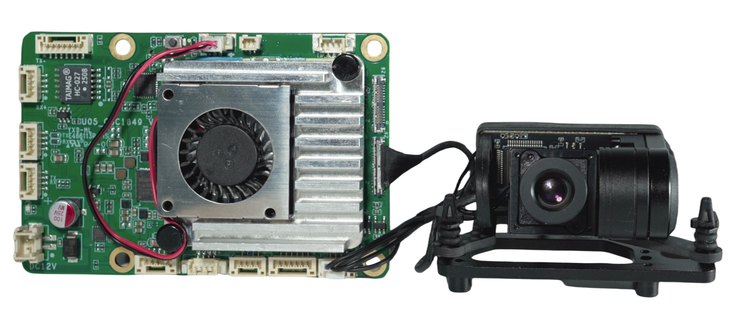

Package list

- AI main board *1
- Single camera payload *1
- Power cable *1
- Serial comm.port*1
- Network comm.port*1
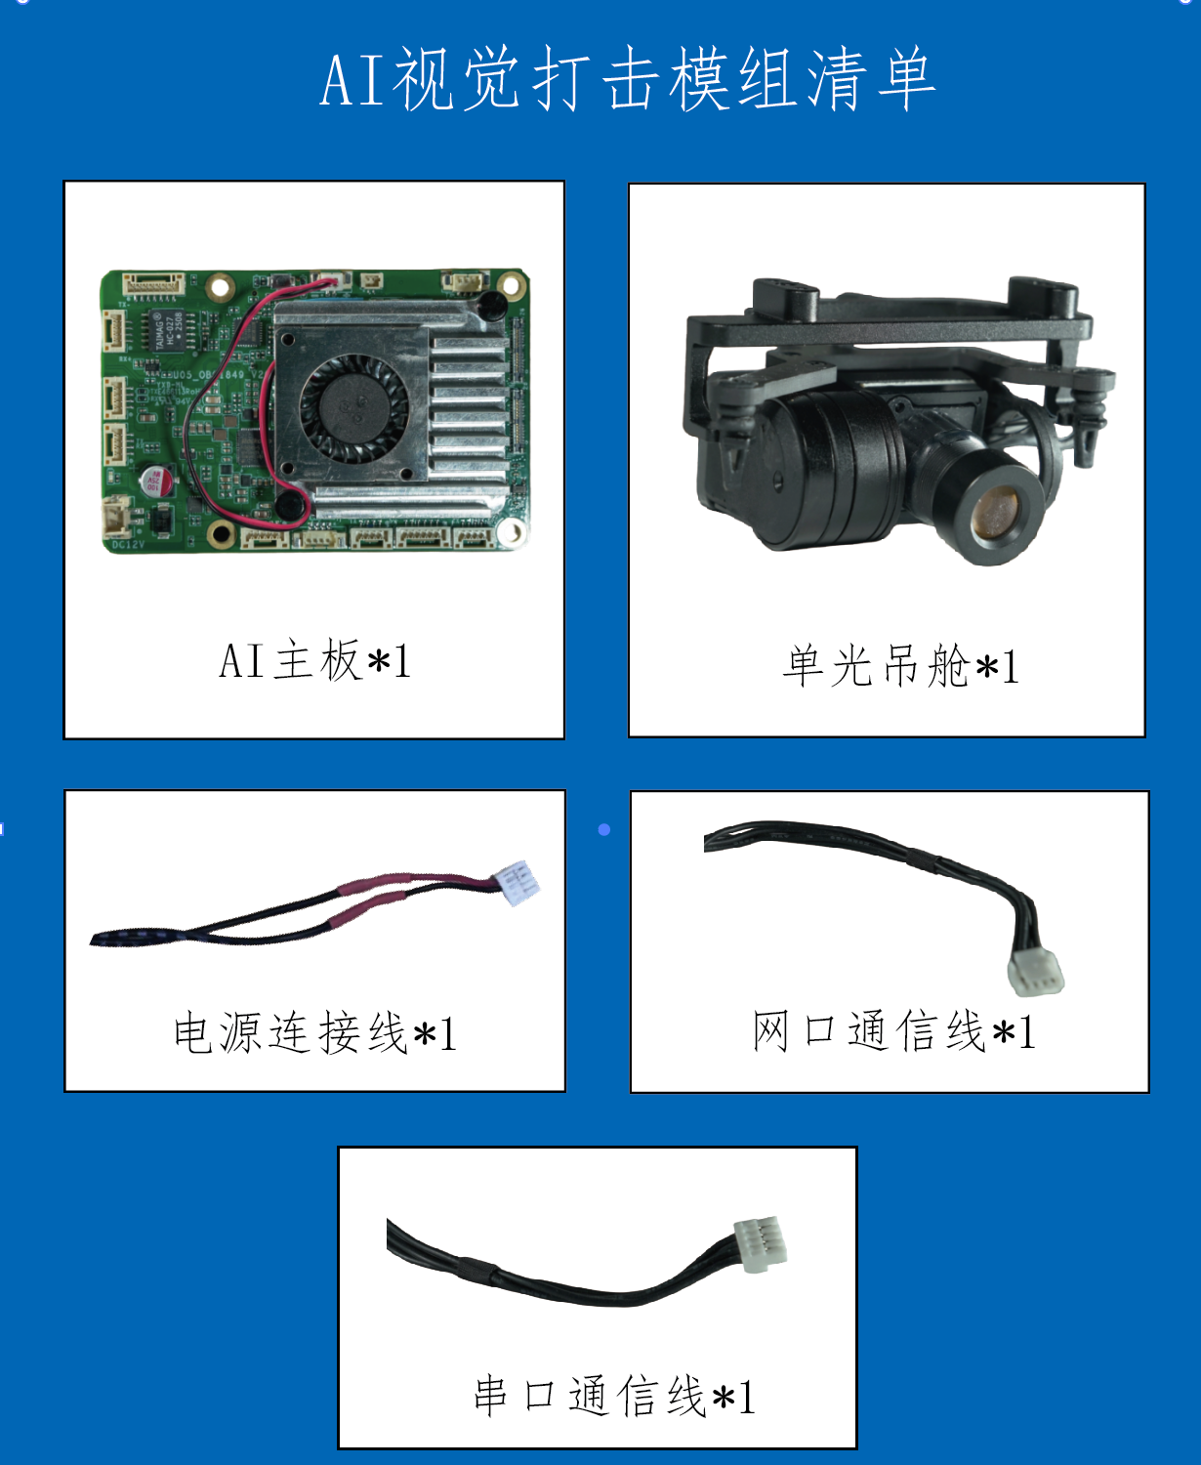
Serial comm.cable
Network comm. cable
Power cable
Camera
AI main board
AI visual strike module packing list

Product Dimensions

AI image processing board
Dimensions (length width height) : 85x56x15mm
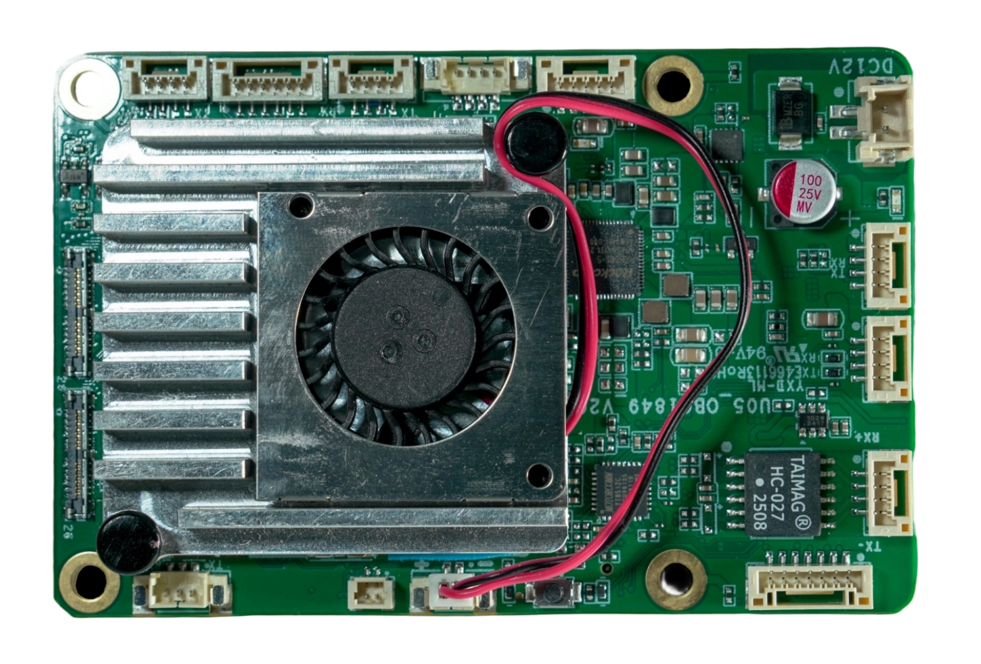
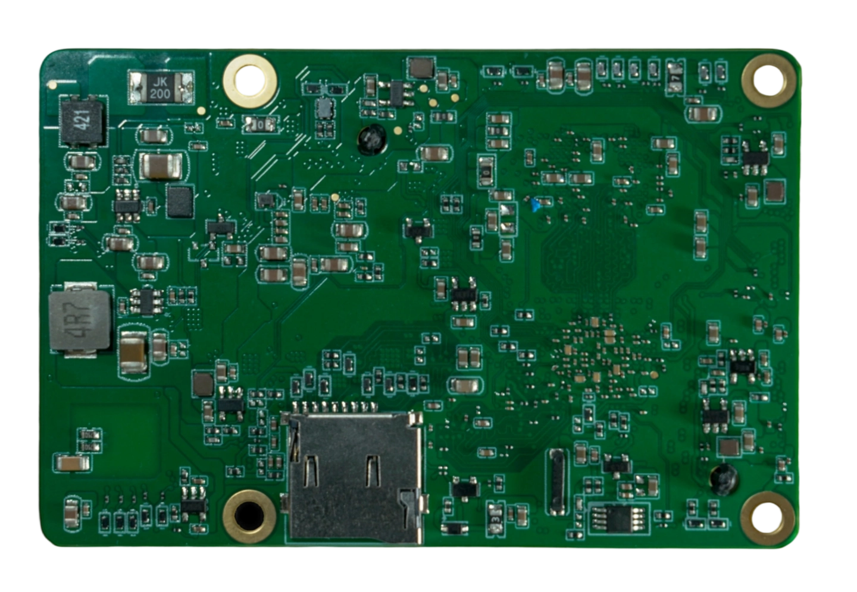
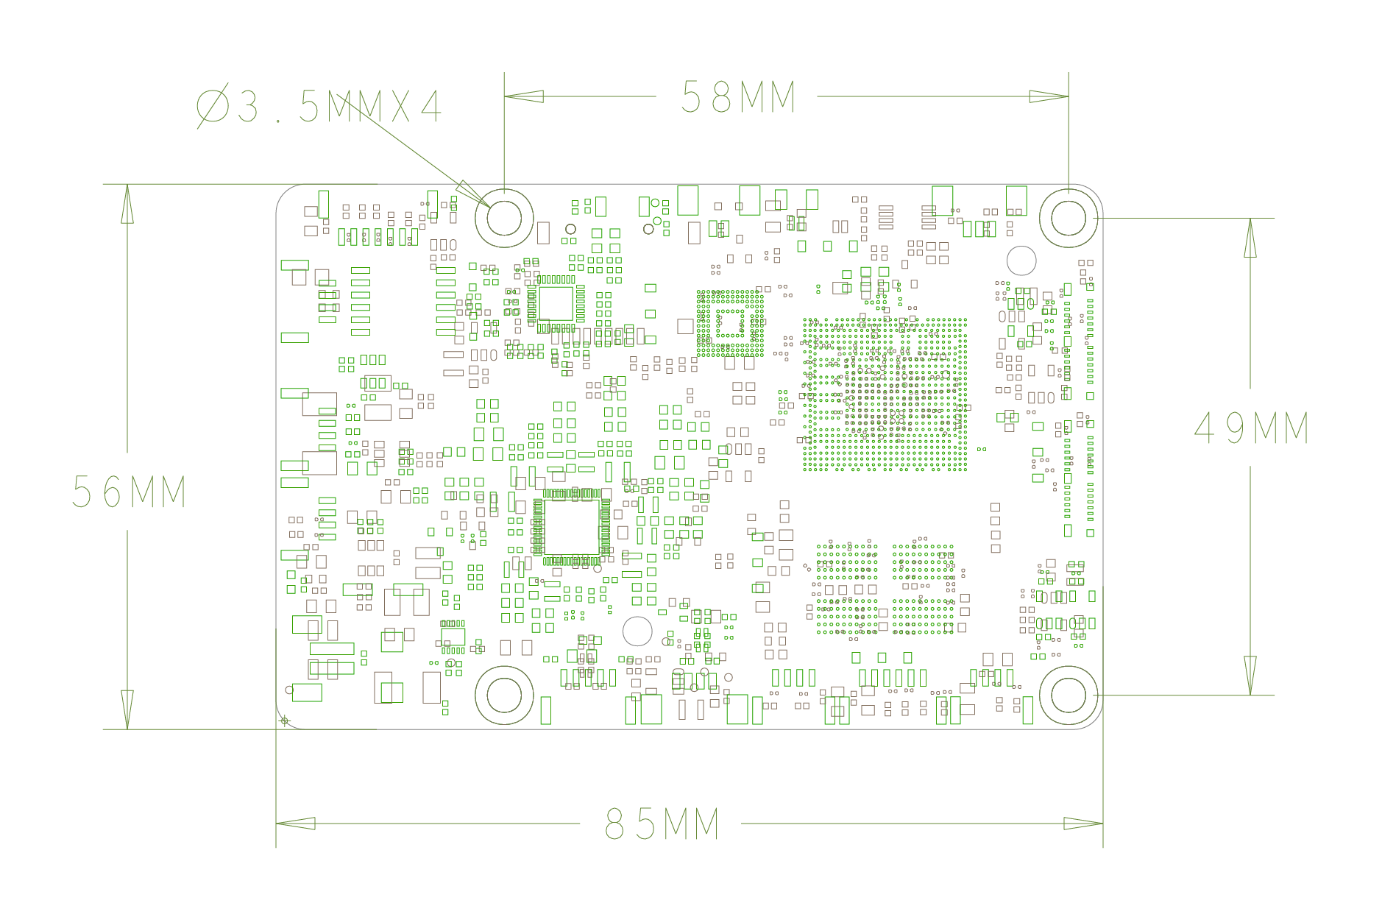

Single camera payloa
Size: 41.8 x 57 x 22.5mm

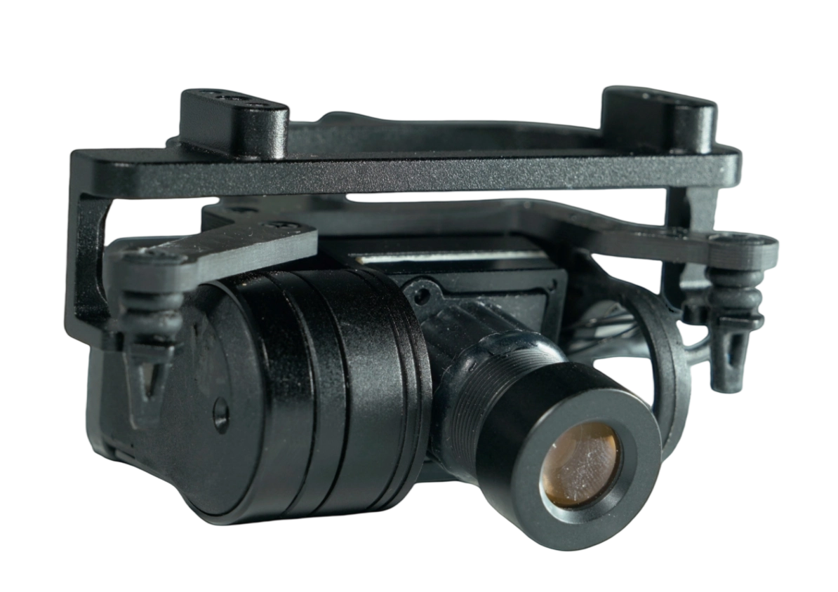

Product Interface Definition

Fan outlet
Backup battery port
I/O port

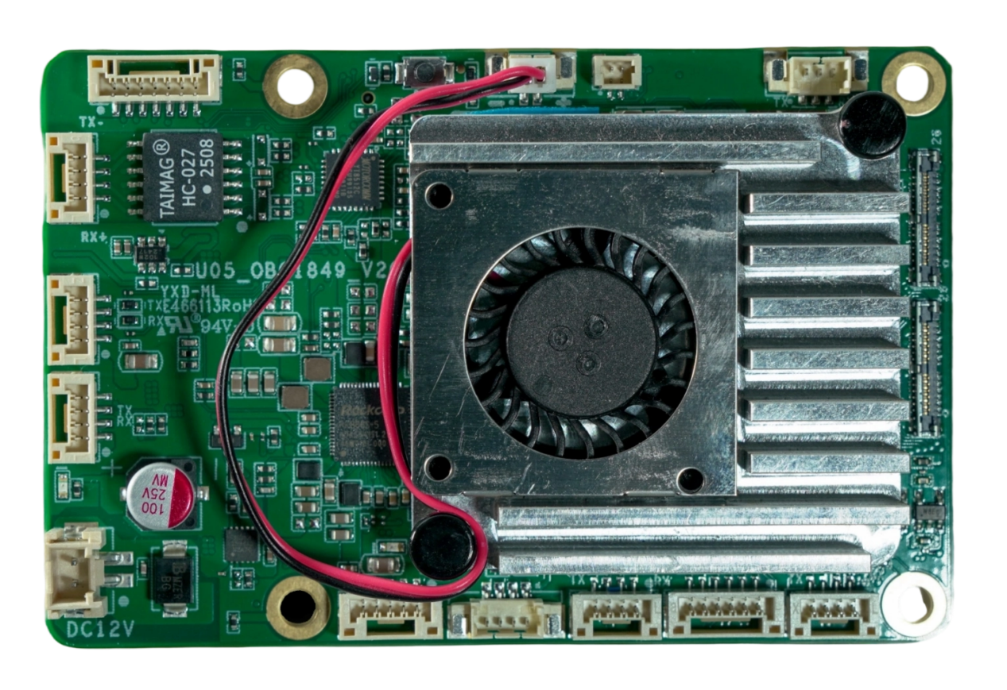
Power input port
Serial Port 2
Network port
Serial Port 1
CAM2
Debug Port
CAM1
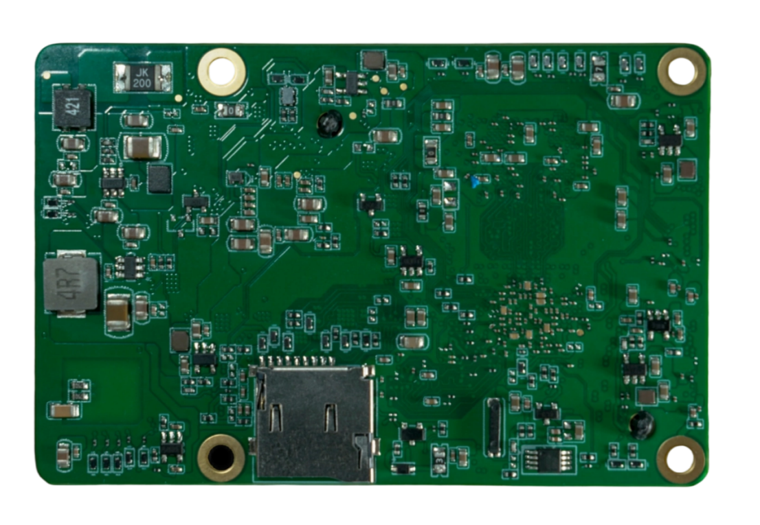
Serial 3
TF Card slot
Serial 6

Serial 4+5
USB_OTG
USB_HOST
AI image processing board interface

AI Image processing board pin definitions
- Network port
Pin | Signal | Voltage
P1 | RX+ | Default
P2 | RX- | Default
P3 | TX+ | Default
P4 | TX- | Default

- Serial Port 1
Pin | Signal | Voltage
P1 | VCC | 5V+
P2 | UART3_RX | 3.3 V
P3 | UART3_TX | 3.3 V
P4 | GND | GND

- Serial Port 2
Pin | Signal | Voltage
P1 | VCC | 5V+
P2 | UART2_RX | 3.3 V
P3 | UART2_TX | 3.3 V
P4 | GND | GND

- Power input port
Pin | Signal | Voltage
P1 | VCC | 12V+
P2 | GND | GND

- USB_HOST
Pin | Signal | Voltage
P1 | GND | GND
P2 | GND | GND
P3 | USB2.0 _DP | Default
P4 | USB2.0 _DM | Default
P5 | VBUS | 5V+

- USB_OTG
Pin | Signal | Voltage
P1 | VBUS | GND
P2 | USB2.0 _DM | Default
P3 | USB2.0 _DP | Default
P4 | GND | GND

- Serial Port 3
Pin | Signal | Voltage
P1 | VCC | 5V+
P2 | UART6_RX | 3.3 V
P3 | UART6_TX | 3.3 V
P4 | GND | GND

- Serial port 4+5
Pin | Signal | Voltage
P1 | UART11_RX | 3.3 V
P2 | UART11_TX | 3.3 V
P3 | UART10_RX | 3.3 V
P4 | UART10_TX | 3.3 V
P5 | GND | GND
P6 | VCC | 12V+

- Serial Port 6
Pin | Signal | Voltage
P1 | UART9_RX | 12V+
P2 | UART9_TX | 3.3 V
P3 | GND | GND

- CAM1/CAM2
Pin | Signal | Voltage
P1 | D2N | Default
P2 | D3N | Default
P3 | D2P | Default
P4 | D3P | Default
P5 | D0N | Default
P6 | GND | GND
P7 | D0P | Default
P8 | GND | GND
P9 | GND | GND
P10 | D1N | Default
P11 | CLKN | Default
P12 | D1P | Default
P13 | CLKP | Default
P14 | MCLK_24M | 1.8 V
P15 | GND | GND
P16 | GND | GND
P17 | PDN | 1.8 V
P18 | I2C_SDA | 1.8 V
P19 | RST | 1.8 V
P20 | I2C_SCL | 1.8 V
P21 | VCCIO | 1.8 V +
P22 | GND | GND
P23 | VCCAF | 2.8 V +
P24 | VCC | 1.2 V +
P25 | VCC_AF | 2.8 V +
P26 | VCC | 1.2 V +

- Backup battery port
Pin | Signal | Voltage
P1 | GND | GND
P2 | VCC_RTC | 3.0 V +

- Fan outlet
Pin | Signal | Voltage
P1 | GND | GND
P2 | VCC | 5.0 V +

- I/O port
Pin | Signal | Voltage
P1 | VCC | 5.0 V +
P2 | I/O1 | 3.3 V
P3 | I/O2 | 3.3 V
P4 | I/O3 | 3.3 V
P5 | I/O4 | 3.3 V
P6 | I/O5 | 3.3 V
P7 | GND | GND

- TF card slot
Pin | Signal | Voltage
P1 | Default | Default
P2 | Default | Default
P3 | Default | Default
P4 | Default | Default
P5 | Default | Default
P6 | Default | Default
P7 | Default | Default
P8 | Default | Default
P9 | Default | Default

Features
- Long-distance identification
Equipped with high-precision optical modules, the maximum recognition distance for human-vehicle targets can reach up to 300 meters.
- Multi-type target recognition
It can autonomously recognize common targets such as people and vehicles, and supports box selection locking and tracking of hundreds of target types, including: buildings, Windows, doors, etc. The recognition capability can be expanded through continuous dataset training to ensure the accuracy of task execution.
- Target box selection
Supports framing targets in visible light images for target tracking and striking.
- Auto-strike
After determining the target, the target strike can be automatically completed through visual guidance without the need for manual intervention.
- Anti-interference strikes
During the strike, even if the drone's communication link or GPS is disrupted, the target can be precisely struck through visual guidance.
- Lightweight integration
Full modular design significantly reduces the cost of deploying AI capabilities.

Technical Parameters
Performance parameters
Support detection of target recognition types | Default human-vehicle, support lock tracking of multiple types of targets
Support target recognition distance | Vehicles: 300m People: 300m
Maximum strike speed | 90km/h
Overall parameters of the AI image processing board
Master computing power (TOPS) | 6
Control Protocol | Private protocol
Support flight control | PX4
Input voltage (V) | 12
Size (length, width, height mm) | 85*56*15
Mounting hole positions (mm) | 3.5 * 4
Gimbal parameters
Gimbal type | Single-axis mechanical stabilization
Image stabilization accuracy | ± 0.005 °
Maximum rotation range | Pitch: ±120°
Maximum rotational speed | ±1500°/s
Dimensions (including shock-absorbing components | 41.8 x 57 x 22.5mm
Installation method | Hoisting
Camera parameters
Sensor (Inch) | 1/2.9
Focal length (mm) | 5mm
FOV | (D)30°
Video output format | 1080P/60fps
Camera size (length, width, height mm) | 18.99 * 18.99 * 26.77

Notes

Daily maintenance
- Dust-proof and stain-proof
- Avoid contamination of the lens with chemicals, oil stains, etc. during use. Wipe and clean the lens surface with a lens cloth immediately after use.
- Do not wipe the optical lens directly with your hands or rough cloth. It is recommended to use a professional lens cleaning kit or a lint-free cloth and alcohol for cleaning.
- Moisture-proof and water-resistant
- Avoid prolonged use in rain, snow, high humidity conditions. If in a damp environment, wipe the surface with a dry soft cloth after work and store in a dry environment.
- Do not soak or rinse the equipment directly.
- Anti-collision
Do not use sharp or hard objects to strike the lens, as this can cause the lens to break and affect its use.

Instructions for Use
- Do not disassemble by yourself
Non-professionals are not allowed to disassemble core components of the pod (such as optical modules, circuit boards), which may result in damage or disqualification from warranty.
- Anomaly handling
If the device shows problems such as overheating, noise, image distortion, etc., stop using it immediately and contact after-sales technical support. Do not forcibly start the device in a faulty state.

