95dB anti-interference GPS

Spec Sheet

Overview
This anti-jamming GPS is a highly integrated ultra-small anti-jamming all-in-one device for applications such as small and medium-sized drones.
The device integrates an antenna array, anti-jamming components and a satellite navigation receiver inside, and supports anti-wideband jamming and positioning of BDS B1 and GPS signals, with core features such as miniaturization, lightweight and low cost. This product is suitable for a variety of critical scenarios:
- Timing security protection: Meeting the strict requirements for high-precision and anti-interference timing in critical industries such as power, communications, and finance.
- Unmanned system navigation assurance: Provide a stable and anti-interference navigation core for unmanned aircraft, unmanned vehicles, and unmanned ships.
- Fleet navigation protection: Enhance the resilience and safety of fleets in confrontational or complex environments.
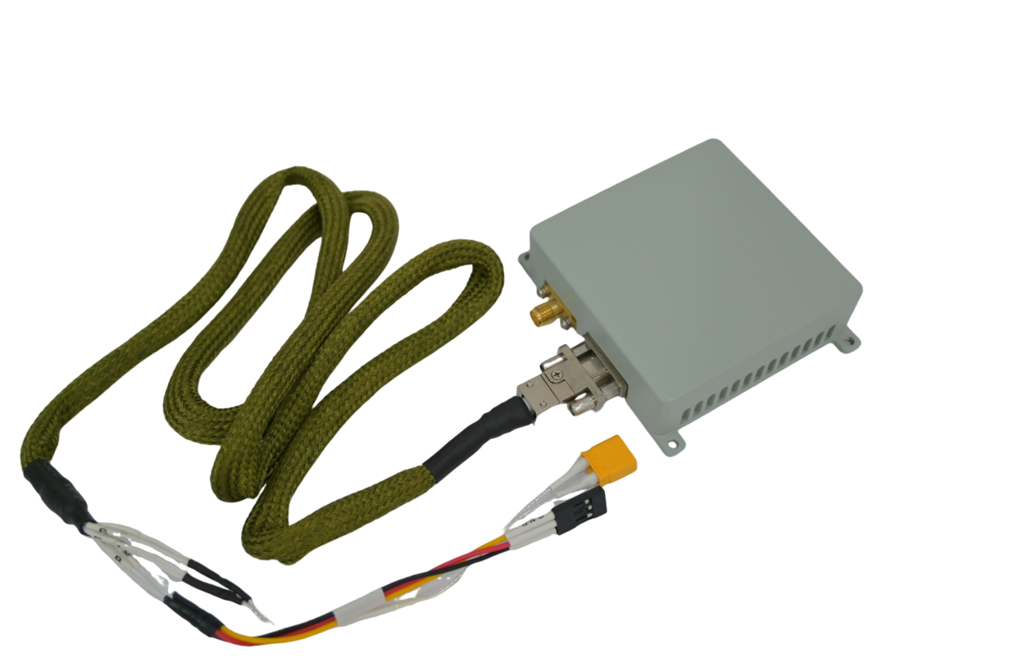

Packaging Checklist
- Anti-jamming module *1
- Data cable *1
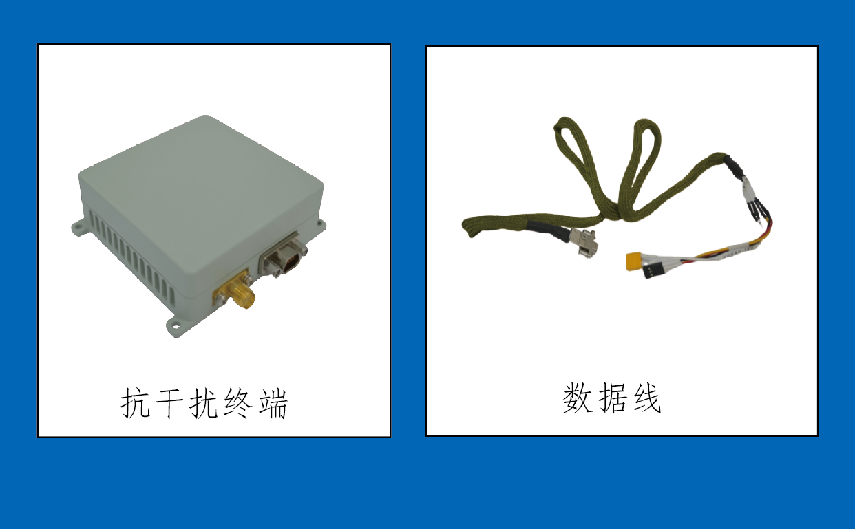
Data cable
Anti-jamming module

Product dimensions and interfaces

Mechanical parameters
Physical properties | - Size: : 65mm×65mm×21mm  - Weight: ≤130g

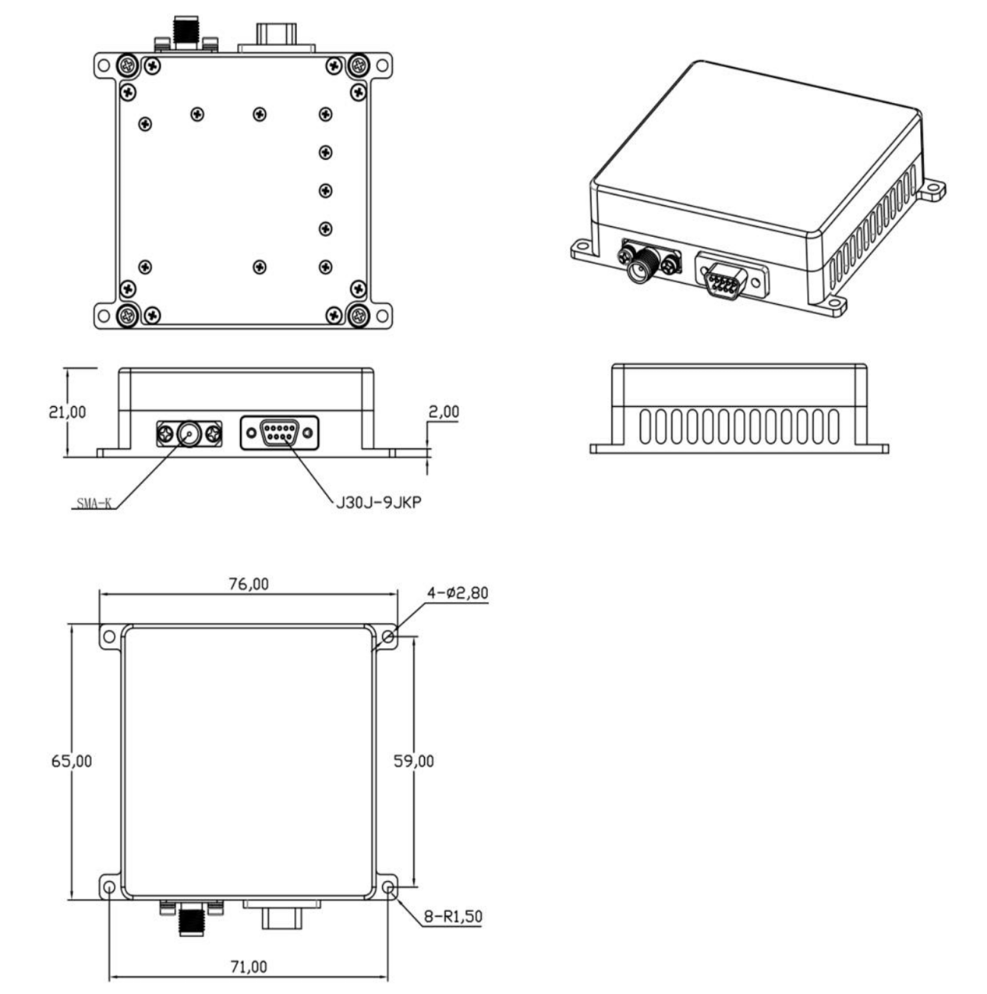

Interface
Interfaces are defined as shown in the table below:
Number | Code | Connector model | Function Description
1 | TX | SMA-KFD | GNSS RF output port, reserved
2 | Data | J30J-9ZKP | 5 to 17V power input, serial port

Power/data interface
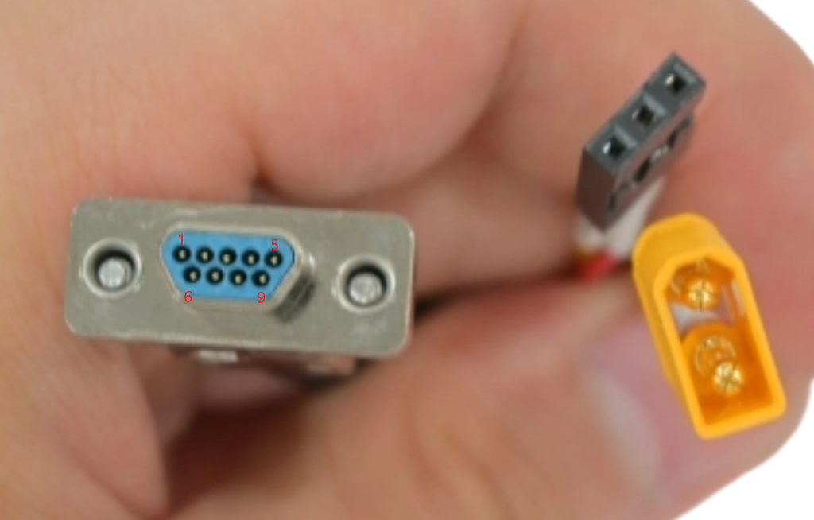
J30J-9ZK connector, pin definitions as follows:
Pin number | Name | Direction | Level | Notes
1 | Positive | Input | 5 to 17V | Suggested 12V
2 | Positive | Input | 5 to 17V | Suggested 12V
3 | Negative | Input
4 | Negative | Input
5 | TXD0 | Output | TTL | Serial port for upgrading
6 | RXD0 | Input | TTL | Serial port for upgrading
7 | RXD1 | Output | TTL | Anti-jamming serial port
8 | TXD1 | Input | TTL | Anti-jamming serial port
9 | GND | Input | TTL | Anti-jamming serial port

Radio frequency interface
- Anti-jamming signal output interface (reserved), with SMA connector, and in one-wire form
- The output B1 / L1 signal level is -70 to -60 DBM

Functional Characteristics
- RNSS signal reception
- Supports receiving RNSS signals from navigation satellite systems such as BDS-3 and GPS.
- Civilian signals supported: BDS B1C, B1I, GPS L1.
- Anti-jamming capability
- Support anti-jamming for B1 and L1 frequencies.
- It can effectively suppress various types of jamming, including narrowband jamming, wideband jamming, pulse jamming, sweep jamming and Gaussian jamming.
- Software upgrade
- Have the ability to upgrade software.
- Support software upgrades for the anti-jamming module and receiver module in the device via serial port.
- System self-check
- With system self-check and status patrol capabilities.
- Anti-burn protection
- It has anti-burn capability and with power of no less than 10W resistant to continuous wave power

Technical Parameters
Category | Parameter Details
Working frequency | B1I: 1561.098MHz  L1/B1C: 1575.42MHz
Anti-jamming performance | Single jamming J/S ratio: ≥95dB  Double jamming J/S ratio: ≥85dB  Triple jamming J/S ratio: ≥80dB
Positioning accuracy | Horizontal ≤10 meters  Elevation ≤15 meters
Speed measurement accuracy | ≤0.2 m/s (95%)
Timing accuracy | ≤100ns (95%)
Operating voltage | Input voltage 5 to 17V
Power consumption | ≤6W
Operating temperature | -40 ° C to +55 ° C
Storage temperature | -55 ° C to +70 ° C
Relative humidity | Temperature 40 ° C; Humidity: 96%
Rain | Meet the rain test requirements of GJB150A

Installation and instructions for use
- Fixed
Use M2 screws for installation fixation.
- Power supply
Power with XT30, supply voltage 5-17V, no more than 17V, 12V is recommended.
- Connection Instructions
- The electrical signal connection between the product and the platform carrier is interconnected through low-frequency data.
- When connecting to a computer using a USB-to-TTL tool, do not plug or unplug the usb while it is powered on to avoid damaging the serial port.
- Conventional connection method for positioning terminals and antennas:
Use the data cable provided with this product to connect to the GNSS serial port of the flight control. Connect the end of the data cable labeled TX to the RX interface of the flight control, the end labeled RX to the TX interface, and the end labeled GND to the GND interface of the flight control.
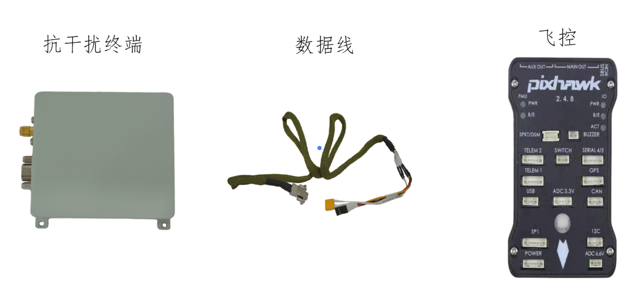
Flight control
Data cable
Anti-Jamming module

- In RF signal access mode, the conventional active antenna connection method:
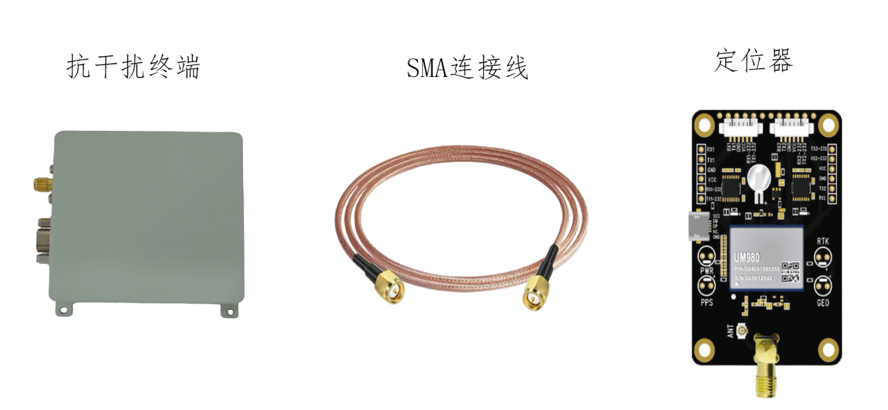
Locator
SMA cable
Anti-Jamming module

- Interface with the flight control protocol
This product outputs either the nmea protocol or the ublox protocol, and the flight control needs to be set to receive either of these protocols. We kindly ask customers to complete protocol integration with our technicians before placing an order.

